Friezes
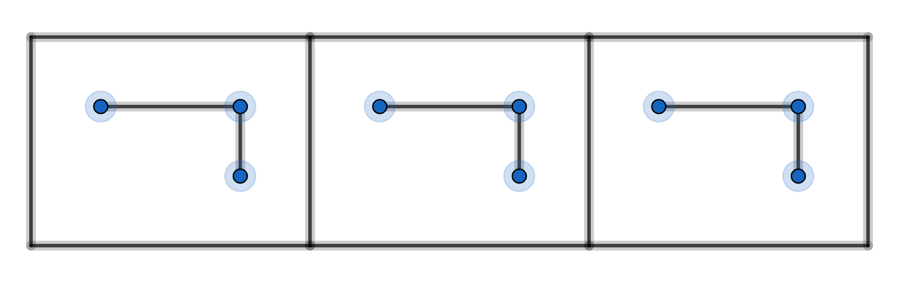

Here we have a row of identical tiles that extends indefinitely in both directions. The diagram shows just three of these tiles. Each tile has a design on it. This is called a frieze.
All friezes have translation symmetry with repeat distancethe length of the tile. (see footnote)
We can classify friezes by their other symmetries which can include:
horizontal mirror line along the middle of the frieze
vertical mirror lines that areapart
centres ofrotation that areapart
glide-reflections with a glide distance

Example 1
no other symmetries

Example 2
horizontal mirror line – can you mark this on the diagram?
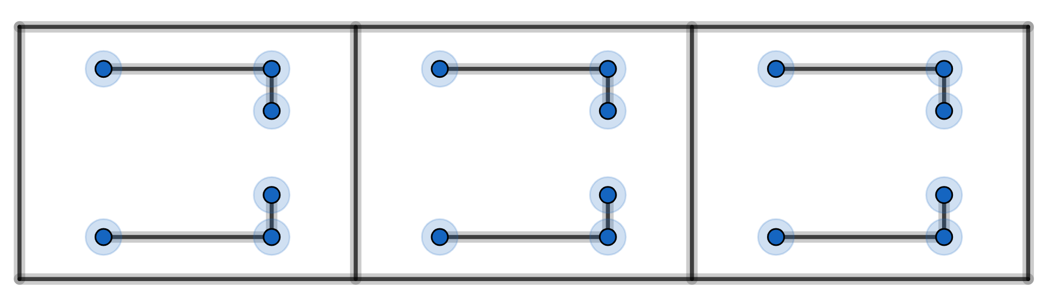

Example 3
vertical mirror lines – can you mark these on the diagram?
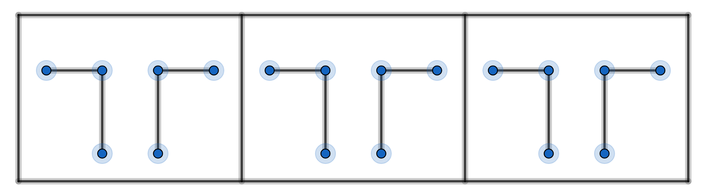

Example 4
rotation – can you mark the centres of rotation on the diagram?
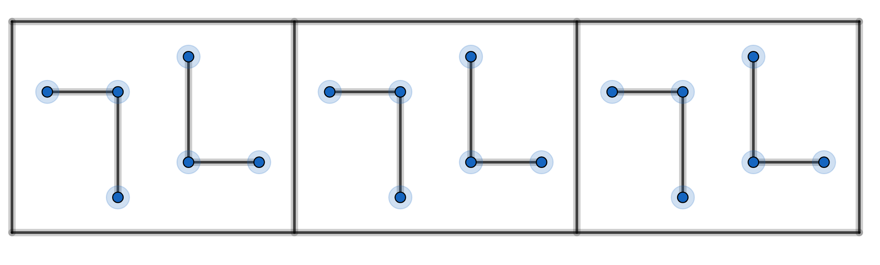

Example 5
glide-reflection
note: a glide-reflection is a combination of a translation and a reflection in a horizontal mirror line

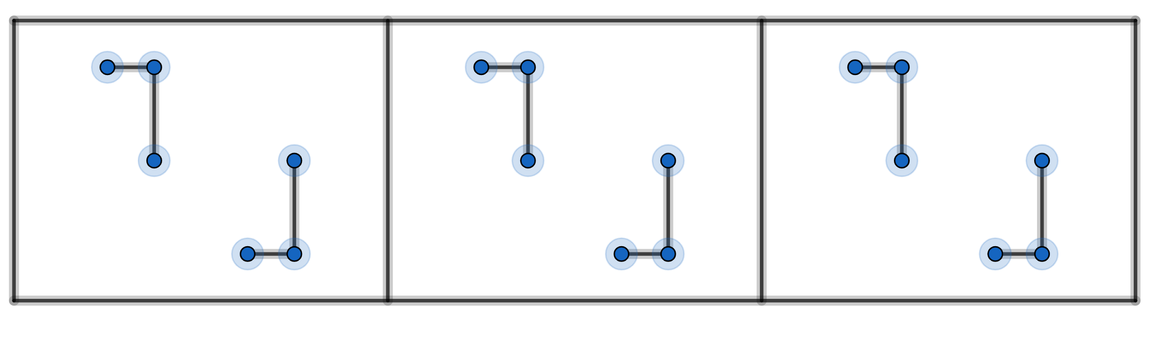

Example 6
horizontal mirror line
vertical mirror lines
rotation
can you mark these on the diagram?
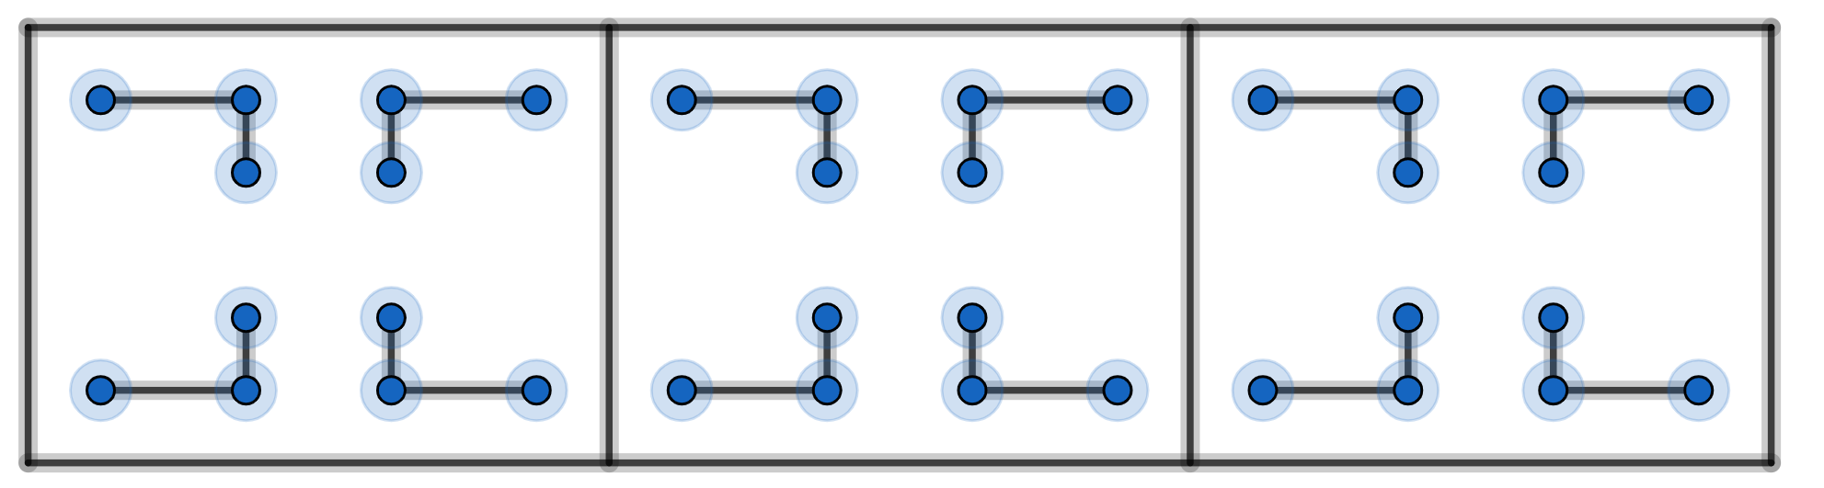

Example 7
vertical mirror lines
rotation
glide-reflection
can you mark these on the diagram?
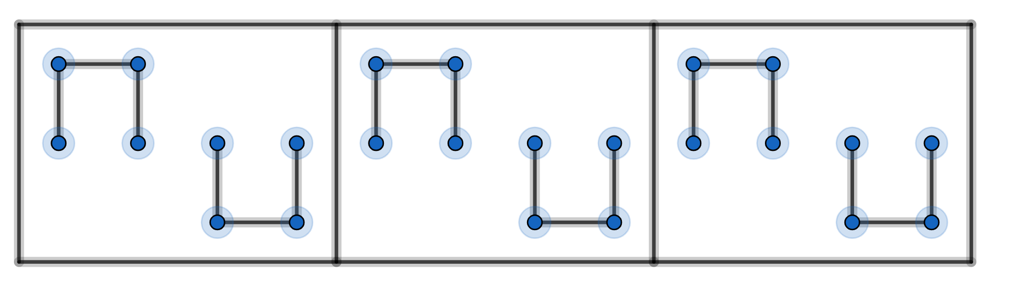
There are no more examples. There are only 7 frieze-symmetry-types. So every possible frieze can be classified as one of these 7 types.
Friezes repeat in one direction. Wallpapers repeat in two directions. It turns out that there are only 17 wallpaper-symmetry-types. So every possible wallpaper can be classified as one of these 17 types.

footnote:
What if our tile had lengthand looked like this?
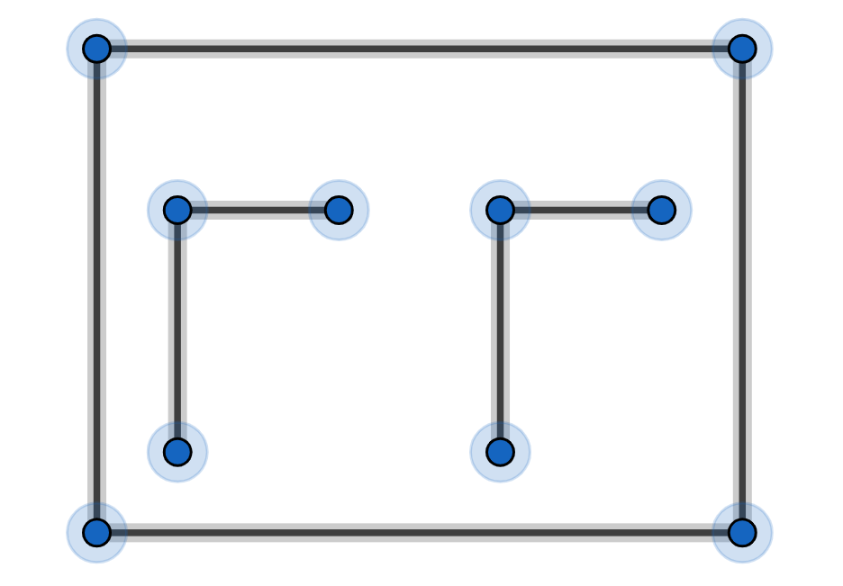

This individual tile has translation symmetry.
To keep things simple we will regard this as two tiles, each of length

